UNIT 6
Input/ Output Organization

The input/output organization of computer depends upon the size of computer and the peripherals connected to it. The I/O subsystem of the computer, provides an efficient mode of communication between the central system and the outside environment. It handles all the input-output operations of the computer system. The most common input output devices are:
Monitor, keyboard, mouse, printer, etc. The devices that are under the direct control of the computer are said to be connected online.

6.1 Peripheral Devices
A peripheral device is also called a peripheral, computer peripheral, input-output device, or I/O device. A peripheral device is an internal or external device that connects directly to a computer or other digital device but does not contribute to the computer's primary function, such as computing. It helps end users access and use the functionalities of a computer. Input or output devices that are connected to computer are called peripheral devices. Since it’s not a core device for the system, the computer can still function without the peripheral, which simply provides extra functions. However, some peripherals such as a mouse, keyboard, or monitor tend to be pretty much fundamental to the interaction between the user and the computer itself.
There are three types of peripherals:
1. Input peripherals: Allows user input, from the outside world to the computer. Example: Keyboard, Mouse etc.
2. Output peripherals: Allows information output, from the computer to the outside world. Example: Printer, Monitor etc.
3. Input-Output peripherals: Allows both input (from outside world to computer) as well as, output (from computer to the outside world). Example: Touch screen etc.

6.2 Basic I/O Interfaces
Interface is a shared boundary between two separate components of the computer system which can be used to attach two or more components to the system for communication purposes. There are two types of interface:
1. CPU Interface
2. I/O Interface

I/O Interface
(An interface is a shared boundary across which two or more separate components of a computer system exchange information.)
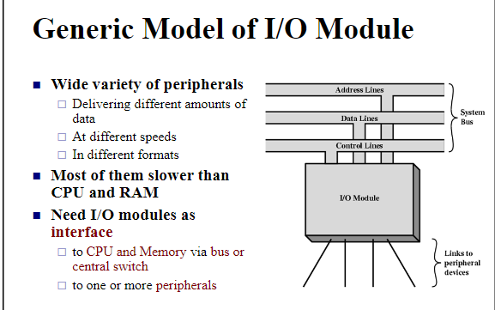
Fig: Model of I/O module
Peripherals connected to a computer need special communication links for interfacing with CPU. In computer system, there are special hardware components between the CPU and peripherals to control or manage the input-output transfers. These components are called input-output interface units because they provide communication links between processor bus and peripherals. They provide a method for transferring information between internal system and input-output devices.
The purpose of communication link is to resolve the differences that exist between the central computer and each peripheral.
The major difference are: sync
- Peripheral are electromechanical and electromagnetic devices and their manner of operation are different from I/O device. Therefore, a conversion of signal values may be needed.
- The data transfer rate of peripheral is usually slower than the transfer rate of CPU and consequently, a synchronization mechanism may be needed.
- Data formats in the peripheral differ from the word format in the CPU and memory.
- The operating modes of peripherals are different from each other and must be controlled so as not to disturb the operation of other peripherals connected to the CPU.
To resolve these differences, computer systems, include special hardware components between the CPU and peripheral to supervise and synchronizes all input and out transfers. These components are called interface units because they interface between the processor bus and the peripheral devices.
The different function of I/O interface are:
- Control timing
- CPU communication
- Device communication
- Data buffering
- Error detection

6.3 I/O Technique
The binary information that is received from an external device is usually stored in the memory unit. The information that is transferred from the CPU to the external device is originated from the memory unit. CPU merely processes the information but the source and target is always the memory unit. Data transfer between CPU and the I/O devices may be done in different modes.
Data transfer to and from the peripherals may be done in any of the three possible ways:
- Programmed I/O.
- Interrupt- initiated I/O.
- Direct memory access (DMA).

6.3.1 Programmed I/O
I/O commands in programmed I/O
- Control
- Test
- Read
- Write
Each data transfer is initiated by an instruction in the program (CPU register and peripherals). All execution happens via CPU instructions. In this method, the CPU stays in a program loop until the I/O device indicates, that it is ready for data transfer. I/O device does not have direct access to memory, all execution happens via CPU instructions.
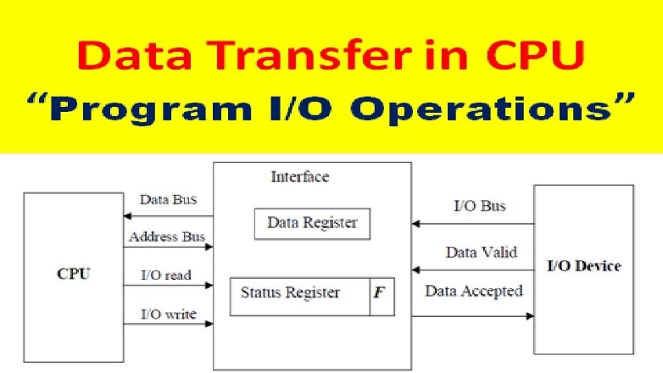
It is useful in order to transfer data between I/O and memory. Here I/O devices place or send data using I/O bus. After placing data on I/O devices. The corresponding I/O devices enables valid line. Data valid line specifies that some information is present in I/O bus. In interface two types of register are used i.e. data register and status register. In status register it maintain flag bit. The value of flag bit is 0 or 1. The information present in I/O bus is placed in data register. Once data register contain some information than the flag bits value will be set as 1. If flag bit is 1. It specifies some information is present in data register. Whenever flag bit is 1, then interface enable data accepted line. The information which is present in data register is send to CPU using data bus. CPU use address bus to access I/O devices. I/O read and I/O write are used for read and write operation.
FLOW CHART
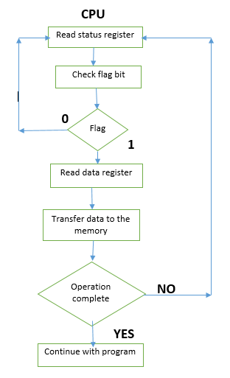
The given flowchart is in prospective of CPU. The CPU check the status register. If the flag bit is 0. It specifies that data is not available in the data register. The CPU checks status flag again and again until the flag bit is 1. Suppose flag bit is 1, then it specifies that data is available in data register. Now, CPU read data from data register and transfer to the memory. After that it check whether the operation is complete or not. If operation is complete it continues with the program, if not it again check the status register for flag bit.
Drawback of Programmed I/O
The main drawback of the Program Initiated I/O was that the CPU has to monitor the units all the times when the program is executing. Thus the CPU stays in a program loop until the I/O unit indicates that it is ready for data transfer. This is a time consuming process and the CPU time is wasted a lot in keeping an eye to the executing of program. To remove this problem an Interrupt facility and special commands are used. This is discussed below.

6.3.2 Interrupt- initiated I/O
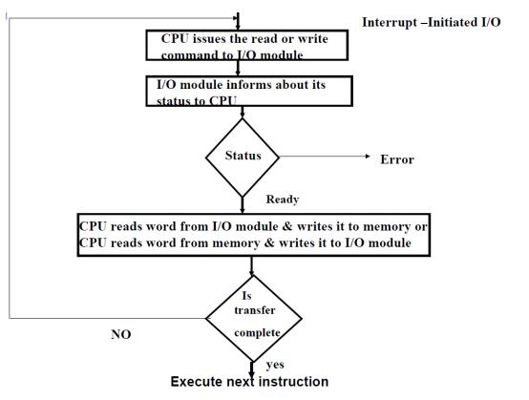
In the programmed I/O method the CPU stays in the program loop until the I/O unit indicates that it is ready for data transfer. This is time consuming process because it keeps the processor busy needlessly. Since in the above case we saw the CPU is kept busy unnecessarily. This situation can very well be avoided by using an interrupt driven method for data transfer.
In interrupt initiated I/O instead of continuous monitoring of CPU, interface will be informed (by CPU) to issue an Interrupt request signal, when data are available from the device. In the meantime the CPU can proceed for any other program execution. The interface meanwhile keeps monitoring the device. Whenever it is determined that the device is ready for data transfer it initiates an interrupt request signal to the computer (CPU). Upon detecting the external interrupt signal, the CPU stops the task it is performing, process the I/O data transfer and then resume the original task it was performing.

6.3.3 Direct memory access (DMA)
Removing the CPU from the path and letting the peripheral device manage the memory buses directly would improve the speed of transfer. In this method, the interface transfer data to and from the memory through memory bus. This technique is known as DMA. To transfer large blocks of data at high speed between external device and main memory DMA approach is often used. DMA allows data transfer directly between I/O device and main memory with minimal intervention of CPU. Direct memory access means CPU grants I/O interface authority to read or write to memory without its involvement, DMA itself controls data transfer between main memory and I/O device. Many hardware systems use DMA such as disk drive controllers, graphic cards, network cards and sound cards etc. In DMA, CPU would initiate the transfer, do other operations while the transfer is in progress and receive an interrupt from the DMA controller when the transfer has been completed. CPU is only involved in beginning and end of the transfer and interrupted only after entire block has been transferred.
FLOW CHART
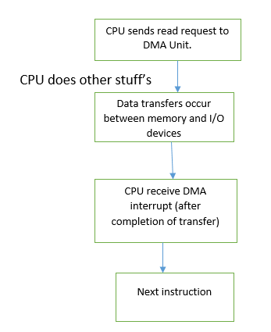
- CPU asks the DMA controller to transfer data between a device and main memory and then CPU proceeds to execute other tasks.
- The DMA controller issues a requests to the right I/O device, waits and manages data transfers between the devices and main memory.
- When data transfer is finished. The DMA controller interrupted the CPU and move it to next instruction.

6.4 I/O Processor
IOP is similar to a CPU except that it is designed to handle the detail of I/O processing. Unlike the DMA controller that must be setup entirely by the CPU, the IOP can fetch and execute its own instruction. IOP instructions are specifically designed to facilitate I/O transfers. Input-Output Processor (IOP) is a processor with direct memory access capability that can communicate with I/O devices. Each IOP takes care of input and output tasks, but IOP send signal to CPU after each task is completed. An input-output processor (IOP) is a processor with direct memory access capability. In this, the computer system is divided into a memory unit and number of processors. Each IOP controls and manage the input-output tasks. The IOP can fetch and execute its own instructions. These IOP instructions are designed to manage I/O transfers only. CPU process the data required for solving the computation task.
Block Diagram of I/O Processor:
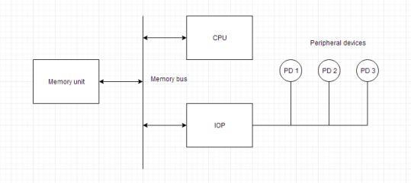
This is a block diagram of a computer along with various I/O Processors. The memory unit occupies the central position and can communicate with each processor. The CPU processes the data required for solving the computational tasks. The IOP provides a path for transfer of data between peripherals and memory. The CPU assigns the task of initiating the I/O program. The IOP operates independent from CPU and transfer data between peripherals and memory. The communication with the memory is similar to the direct memory access method. In large scale computers, each processor is independent of other processors and any processor can initiate the operation. The CPU can act as master and the IOP act as slave processor. The CPU assigns the task of initiating operations but it is the IOP, who executes the instructions, and not the CPU. CPU instructions provide operations to start an I/O transfer. Commands are stored in memory. CPU informs the IOP where to find the commands in memory.

6.5 I/O Ports (Serial, Parallel, HDMI, VGA, USB 2.0 and 3.0)
A connection point that acts as interface between the computer and external devices like mouse, printer, modem, etc. is called port. Alternatively referred to as I/O address, I/O port, and I/O port address. The input/output port is a memory address used by software to communicate with hardware on your computer. In your computer there are 65,536 memory ports that are numbered from 0000h to FFFFh.
The main communication ports of input and output are serial port, parallel port, VGA port, USB port, HDMI port etc.
To view the computer I/O addresses in Windows, open the Device Manager, click View at the top of the Device Manager window, click Resources by type, and then select Input/Output (IO). You will see output similar to the picture shown below.
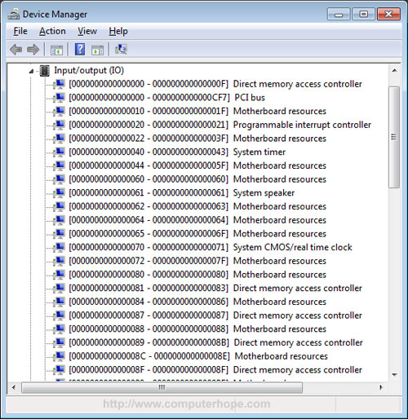

6.5.1 Serial Port (already covered in UNIT 1)
A serial port is an interface that allows a PC to transmit or receive data one bit at a time. They are 9-pin connectors that relay information, incoming or outgoing, one byte at a time. It is one of the oldest types of interfaces and at one time was commonly used to connect printers and external modems to a PC. Modern serial ports are used in scientific instruments, shop till systems such as cash registers and applications like industrial machinery systems. Compared to a parallel port, the data transfer rate of a serial port is slower. A parallel port could support rates up to 100 kilobytes per second, while serial ports only supported 115 kilobits per second (kbps). Later, enhanced technology pushed serial speeds to 460 kbps. Normally, a serial port is a male port, while a parallel port is a female port.

6.5.2 Parallel port (already covered in UNIT 1)
The parallel port is found on the back of the computer and is part of the motherboard. On PCs, the parallel port uses a 25-pin connector (type DB-25) and is used to connect printers, and other devices that need relatively high bandwidth. The data is transmitted over a parallel cable extending no more than the standard 6 feet. If the cable is too long, the integrity of the data can be lost. It is often called a centronics interface after the company that designed the original standard for parallel communication between a computer and printer. Parallel ports became popular because they were able to transmit data in parallel at a faster rate than was standard at the time. In the past, the parallel port was widely used for printers and occasionally for connecting other devices externally, but today parallel port is replaced by USB.

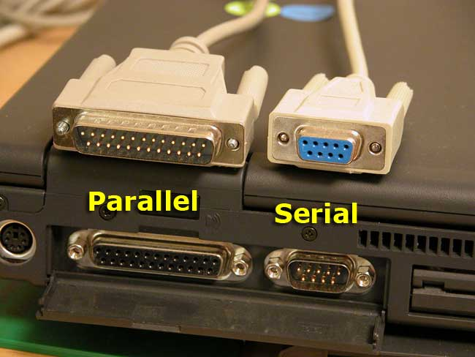
Figure: parallel and serial port

6.5.3 HDMI
HDMI stands for High Definition Multimedia Interface. It is an HD signal that is most frequently used to transfer audio and visual content from one device to another such as a computer or TV cable box, to a computer monitor, TV or projector. The HDMI interface allows a port to send high-resolution digital video, theatre-quality sound and device commands through an HDMI connector and down a single HDMI cord, each designed to support a video resolution and features in the HDMI specification.
There are different sized HDMI ports, including mini-HDMI and micro-HDMI. However, the majority of the time, the port will be the standard full size. There are different versions of HDMI ports, which usually varies depending on how old your model is.
Here's a breakdown of the key specs of HDMI versions:
- HDMI 1.0-1.1: Up to 1080p at 60Hz
- HDMI 1.2-1.2a: Up to 1080p at 60Hz
- HDMI 1.3-1.4b: Up to 4K at 30Hz
- HDMI 2.0-2.0b: Up to 4K at 60Hz
- HDMI 2.1: Up to 4K at 120Hz and 8K at 120Hz

6.5.4 VGA
Short for Video Graphics Adapter or Video Graphics Array, VGA is a popular display standard developed by IBM and introduced in 1987. VGA provides 640 x 480 resolution colour display screens with a refresh rate of 60 Hz and 16 colours displayed at a time. If the resolution is lowered to 320 x 200, 256 colours are shown. VGA utilizes analog signals, which means it is only capable of lower resolutions and lower quality display on screens.
The VGA/SVGA cable and connector will typically look like on the monitor, and on the back of the computer. The VGA standard has been replaced by SVGA (super VGA) and, although these cables and connectors are still referred to as VGA, they are technically SVGA (super VGA).
VGA debuted with 640x480 pixels and 16 or 256 colours. This is still the mode PCs boot into, and it is also used in Safe Mode with the display driver disabled. IBM later introduced XGA (1024x768), and over the years, more resolutions were added that were fractions or multiples of the total number of pixels in VGA and XGA resolutions.
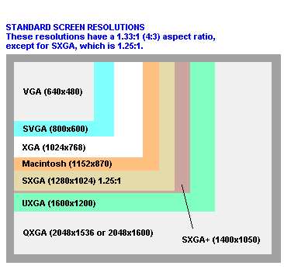
The illustration shows the 15-pin VGA connector, its pin assignments, and size dimensions. As can be seen, the VGA connector has 15 holes and each hole (pin) has its own function as explained in the below chart.
Pin | Function
1 | Red Video
2 | Green Video
3 | Blue Video
4 | Monitor ID 2
5 | TTL Ground (monitor self-test)
6 | Red Analog Ground
7 | Green Analog Ground
8 | Blue Analog Ground
9 | Key (Plugged Hole)
10 | Sync Ground
11 | Monitor ID 0
12 | Monitor ID 1
13 | Horizontal Sync
14 | Vertical Sync
15 | Monitor ID 3

6.5.5 USB
Short for universal serial bus, USB is a plug and play interface that allows a computer to communicate with peripheral and other devices. USB-connected devices cover a broad range; anything from keyboards and mice to music players and flash drives. USB may also send power to certain devices, such as powering smartphones and tablets and charging their batteries. The first commercial release of the Universal Serial Bus (version 1.0) was in January 1996. This industry-standard was then quickly adopted by Intel, Compaq, Microsoft, and other companies. All modern computers have at least one USB port. Today, many different USB devices connect to your computer. E.g. mouse, printer, keyboard, external drive etc. Older USB 1.1 devices and cables are, for the most part, physically compatible with USB 2.0 hardware. However, the only way to reach USB 2.0 transmission speeds is if all devices and cables being connected to each other support USB 2.0. In other words, the transmission speed falls to the older of the two technologies. This makes sense, since you can't pull USB 3.0 speeds out of a USB 2.0 cable, nor can you get USB 2.0 transmission speeds using a USB 1.1 cable.

6.5.5.1 USB 2.0
USB 2.0 is a Universal Serial Bus (USB) standard. Almost all devices with USB capabilities, and nearly all USB cables, support at least USB 2.0. Devices that follow to the USB 2.0 standard have the ability to transmit data at a maximum speed of 480 Mbps. This is faster than the older USB 1.1 standard and much slower than the newer USB 4 standard. USB 1.1 was released in August 1998, USB 2.0 in April 2000, USB 3.0 in November 2008, and USB 4 in August 2019.

6.5.5.2 USB 3.0
USB 3.0 is a Universal Serial Bus (USB) standard, released in November 2008. Most new computers and devices being manufactured today support this standard, which is often referred to as SuperSpeed USB. Devices that follow to the USB 3.0 standard can theoretically transmit data at a maximum rate of 5 Gbps (5,120 Mbps), but the specification considers 3,200 Mbps more reasonable in everyday use. USB 3.2 is an updated version of USB 3.1 (SuperSpeed+), though USB4 is the latest USB standard. USB 3.2 increases this theoretical maximum speed to 20 Gbps (20,480 Mbps), while USB 3.1 comes in at a maximum speed of 10 Gbps (10,240 Mbps). USB 3.0, USB 3.1, and USB 3.2 are the "old" names for these standards. Their official names are USB 3.2 Gen 1, USB 3.2 Gen 2, and USB 3.2 Gen 2x2, respectively.

